MFM2P Name:_____________________

**Linking Cube Towers**

1. Roll a die: This is your starting value. Get this number of cubes in one colour and a lot of cubes in another colour.

2. Roll a die: This is your RoC.

3. Construct linking cube towers using the numbers from above. Complete the **table** for each step then **graph** the relationship and write down an **equation** (rule) to represent it.

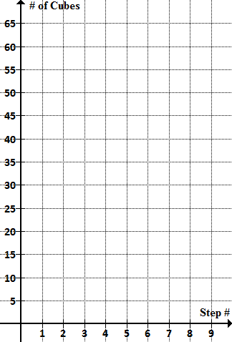

|  |  |
| --- | --- |
| **Step** | **# Cubes** |
|  |  |
|  |  |
|  |  |
|  |  |
|  |  |
|  |  |

Equation: ____________________________

4. Repeat the entire process using the **same grid** for your graph.

Roll a die: This is your starting value.

Roll a die: This is your RoC.

|  |  |
| --- | --- |
| **Step** | **# Cubes** |
|  |  |
|  |  |
|  |  |
|  |  |
|  |  |
|  |  |

Equation: ____________________________

5. Do your two lines ever cross? Explain why or why not.

Prove it using your equations.

Equation 1: ____________________________ Equation 2: ____________________________

6. Fiona and Evelyn make some linking towers and came up with the following equations:

TOWER 1: and TOWER 2: 

1. Explain what each number in each equation represents.
2. How many cubes will be in tower 2 at step 7?
3. At what step will tower 1 have 222 cubes? Use algebra!
4. Determine at what step the towers will be the same height and how many cubes will be in each tower.

7. Work with a partner. Each of you should roll a die twice and record the results.

**YOU** **YOUR PARTNER**

Roll a die: Starting value Roll a die: Starting value

Roll a die: RoC Roll a die: RoC

1. Without building the towers or graphing, decide if your towers will ever be the same height at the same step number. Explain your reasoning.
2. What one number from above could you change to change your answer to part (a)?
3. Analyze the following situations – will the towers ever be the same height at the same step? Make your thinking visible.

i) **YOU** **YOUR PARTNER**

Starting value: 4 Starting value: 4

RoC: 5 RoC: 7

ii) **YOU** **YOUR PARTNER**

Starting value: 5 Starting value: 7

RoC: 4 RoC: 4

iii) **YOU** **YOUR PARTNER**

Starting value: 5 Starting value: 7

RoC: 8 RoC: 4

iv) **YOU** **YOUR PARTNER**

Starting value: 5 Starting value: 7

RoC: 4 RoC: 8