Math at Work 10 – Stomp Rockets Project

Description

Students stomp or jump on an empty 2-liter soft drink (“pop”) bottle and force the air inside through connected plastic pipes to propel a paper rocket.

Launcher Materials

* Empty (and rinsed) 2-liter plastic soft drink bottle
* 2 1/2” PVC tee connectors
* 1 1/2” PVC connector
* 2 1/2” PVC caps
* 5’ length of 1/2” PVC pipe
* Duct tape

The PVC pipe will be cut into smaller pieces. The PVC parts do not have to be cemented together. Friction will hold the parts with occasional adjustments. If the end of the bottle is accidentally squashed, the bottle becomes difficult to re-inflate and has to be replaced. The launch rod can be aimed at different angles by tilting to one side or another. Rotating the entire launcher horizontally changes its direction.

Constructing the Launcher

1. Cut the PVC pipe into the following lengths:

* 3 pieces 12” long
* 3 pieces 6” long

1. Insert the end of one 12” pipe a few inches into the neck of the bottle and tape it securely with duct tape.
2. Follow the construction diagram below for assembly of the launcher.

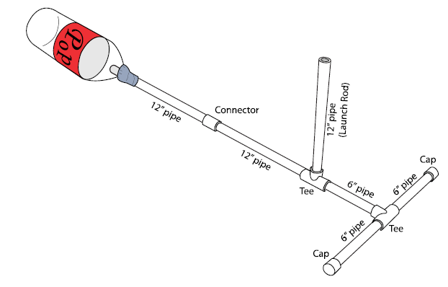

Constructing the Rockets

Several 12-inch pieces of PVC will be used to make separate rocket forming tubes. These will help you make perfect rockets every time. It's nice to have a few on hand so more than one person can be working on a rocket at the same time.  
  
You want the forming tubes to be slightly bigger than the tube that the rockets get launched from. This is accomplished by taping a sheet of 8 1/2" by 11" paper around each forming tube.   
  
Print out and make plenty of copies of the PDF rocket template onto cover stock paper (a bit more heavy weight than regular paper). There are basic building instructions on the rocket template. Decorate and cut out areas as directed.  
  
Roll the rocket body section onto forming tube, with the bottom of rocket (where the fin placement lines are located) just above the end of the forming tube. Tape the body tube together, but NOT to the forming tube. Fold the fins and tape them in place on the fin placement lines. Make a nose cone from a small circle of paper and place a cotton ball or a bit of play-doh into it and then tape it to the top of the paper tube, and cover with a couple of pieces of tape. The additional mass to the nose increases its flight stability. Remove rocket from forming tube.

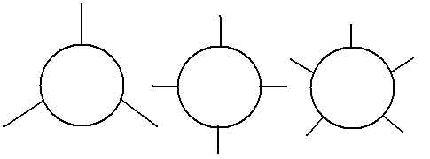Students can experiment with their own rocket designs. You can change the shape and number of fins you will be using! Anywhere from 3 – 5 is optimal. Use one of the two methods shown below, or devise your own way of attaching fins!



**Launching Rockets**

When using the launcher, place it in an open space. If using inside, aim the launch tube at a low angle towards a far wall. Select a target to aim for. If using outside (choose a calm day), the launcher should be aimed at a clear area. For fun, place a basketball in the landing zone. Tell students to imagine the ball is the planet Mars (it’s the right color!) and have them launch their rocket to Mars.

Make sure the student doing the launching and any other students near the launcher are wearing eye protection. Do not permit any students to stand in front of the launcher or in the landing zone while “launch operations” are taking place.

While everyone is making rockets, we suggest you establish a launch order. We suggest that you have people sign up for launch order only after they have completed a rocket. You could say something like: "Come up and show me your rocket, and I’ll sign you up for a launch time."

It’s important to establish who is launching when before you go to the launch site. (At the launch site, things can get a little chaotic.) Have everyone fill in the names, in order, on their data sheets before going to the launch site.

Flight Mission Possibilities:

* Maximum Altitude
* Precision Landing (basketball planet)
* Maximum Distance Downrange - To get the greatest height, people held the launcher so it pointed straight up. To get the greatest distance, they’ll need to change the angle at which they hold the rocket launcher. What angle gives them the greatest distance? Encourage them to experiment to find out.
* Longest Air Time

**Determining Launch Altitude**

Using a clinometer and basic mathematics, students will indirectly measure the altitude achieved by the rockets they construct. With two clinometers in different locations, accuracy of the estimates can be improved. If you have a flagpole or tall building near the launch site, have students practice taking measurements of the angle between the ground and the top of the pole or to one of the upper corners of the building. When students are comfortable using the tracker and are consistent in measuring, they are ready to track rockets. Lay out a baseline from the launch site. A longer baseline provides better measurements than a shorter one.

The rocket is launched and a tracker, some distance away, sights the rocket and determines the angle between the ground and the rocket at the top of its flight.

When the rocket is launched, the tracking students aim their clinometers at the highest point in the flight of the rocket. The angles of the clinometers are read and the data recorded. Have the students help each other in reading the angle. For greater accuracy, have students average their estimates. Calculations can be done back in the classroom.

As students compare estimates, errors will be detected. Their altitude estimates are only as accurate as the measurements of the angles. Precise angle measurements are difficult, especially when the rocket is small and the altitude is great. A disagreement of 10 percent in the estimated altitude between trackers is acceptable.

Assuming perfect conditions, the rocket goes straight up from the launch pad. This creates a right angle with Earth and the computed altitude should be accurate. However, altitude estimates for rockets that stray from the vertical will be less accurate. To minimize wind effects, two tracking stations can be used. Each are placed at equal distances from the launcher. The line connecting the two sites should be parallel to the wind. The students at each site track the rocket. Assuming the wind causes the rocket to drift over the up wind station, that tracker will get a higher angle than if the rocket had climbed straight up. The student at the down-wind station will get a lower angle. Their estimates are averaged together to correct for wind effects. The diagram below shows how the two tracking stations coordinate to improve altitude estimates.



**Calculating Height with a Scale Diagram**

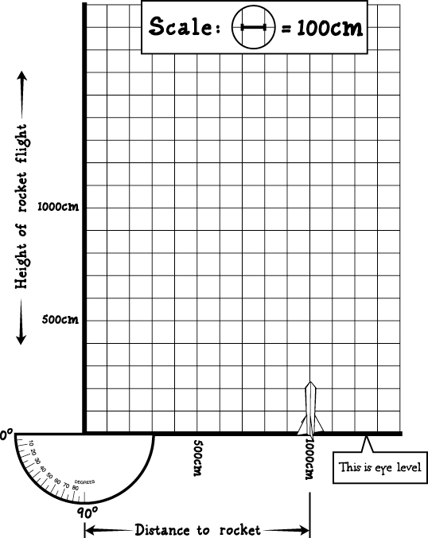Use a piece of graph paper or other grid to construct a scale diagram. Each square on the grid could represent 1 or 2 meters. Imagine that your eye is in the lower left-hand corner of the grid. The line at the bottom of the grid is a line parallel to the ground, right at the level of your eyes. Draw a small rocket on the ground at the distance you are standing from the launch pad. Draw a line straight up from the rocket. Use a protractor to draw a line from your eye at the angle you sighted the rocket at its highest point. You can measure the height of the rocket from the grid on the paper.

The height of the triangle is how high the rocket flew above eye level. To get the height the rocket flew above the ground, people need to add on the distance from the ground to the eye. We've provided an average value for this number. People could get a more accurate measurement by measuring the eye level of all their measurers and figuring out the measurers’ average eye level. But that's more accurate than people probably need to get!

**Calculating Height with Time**

A simple way of estimating a rocket’s altitude is by counting the seconds the rocket is flying through the air from launch until it reaches the ground. This is not the most accurate method for measuring altitude, since a rocket which has a prolonged glide back to the ground may be in the air longer than a rocket which traveled higher, but free-falls back to the ground. Nonetheless, counting seconds and working with a simple formula for predicting height with objects falling near the Earth’s surface is useful pedagogically.

The formula is as follows, counting time from launch to the moment the rocket lands:

Height (max altitude) = (½)(32 ft/s2)(time in sec/2)2.

Using meters, the formula is:

Height (max altitude)= (½)(9.8 meters/s2)(time in sec/2)2.

As an example, if the rocket is in the air for 2 seconds, the height it reached is approximately:

(½)(32 ft/s2)(2 s/2)2 = (16 m/s2)(1 s2) = 16 feet or

(½)(9.8 m/s2)(2 s/2)2= (5 m/s2)(1 s2) = 5 meters.

If the rocket is in the air for 4 seconds, the height it reached is approximately:

(½)(32 ft/s2)(4 s/2)2= (16 ft/s2)(4 s2) = 64 feet or

(½)(9.8 m/s2)(4 s/2)2 = (5 m/s2)(4 s2) = 20 meters.

**Calculating Height with Trigonometry**

Using a simple formula, the altitude is calculated.

a (altitude) = tangent of A (angle) X b (baseline)

a = tan A (b)

To solve the formula, students look for the angle they measured on a tangent table. For example, the angle is 30 degrees. The tangent is 0.5774. They use that number in the equation. The baseline (distance from the launch pad to the clinometer) is measured with a tape measure. In our example the distance is 25 meters.

a = 0.5774 X 25 m = 14.435 m

The altitude reached by the rocket is 14.435 meters.

**Helpful Resources:**

|  |  |
| --- | --- |
| **Clinometers** | |
| http://www.enasco.com/prod/images/products/7A/AC140231.jpg | http://www.nhbs.com/images/jackets_orig/kpics/193256.png |
| Nasco Clinometer  http://www.enasco.com/product/TB16572M | Invicta Clinometer Mk1  http://www.invictaeducation.com/product/clinometer-one |
| http://ecx.images-amazon.com/images/I/710XSe77SZL._AA1500_.jpg |  |
| Estes AltiTrak  http://www.estesrockets.com/002232-altitraktm |  |

**Sources:**

NASA - Pop! Rocket Launcher Directions http://www.nasa.gov/audience/foreducators/topnav/materials/listbytype/Pop_Rocket_Launcher_Directions.html

NASA -Launch Altitude Tracker

http://www.nasa.gov/audience/foreducators/topnav/materials/listbytype/Launch_Altitude_Tracker.html

Instructables – Paper Stomp Rockets – Easy and Fun!

http://www.instructables.com/id/Paper-Stomp-Rockets-Easy-and-Fun/

Bottle Blast Off!

http://www.exploratorium.edu/math_explorer/tfl_BBO_leaderGuide.html

Northrop Grumman Aerospace Systems – Rocket ‘Round the Clock

http://www.northropgrumman.com/CorporateResponsibility/CorporateCitizenship/Education/Documents/pdfs/Rocketry_Guide.pdf