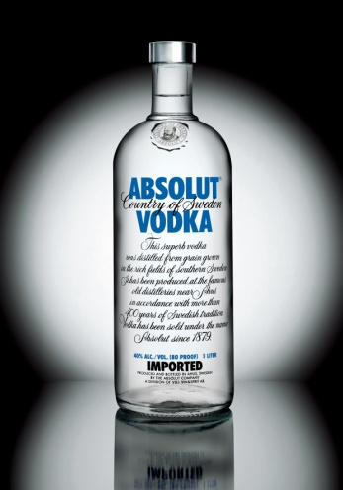 | 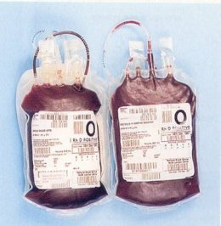
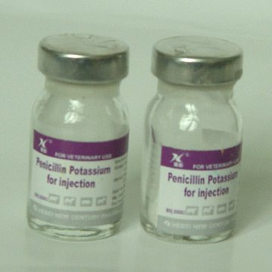 | 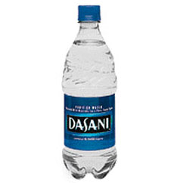
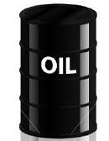 | 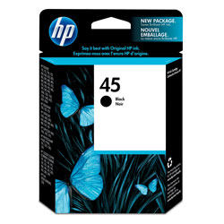
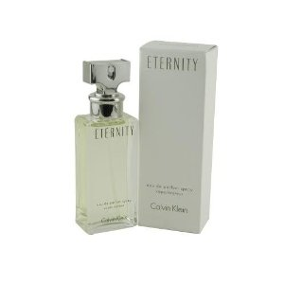 | 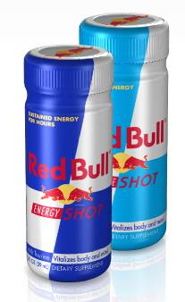

Teacher Notes

Ask students to cut out and rank the liquids from most expensive to least expensive. Discuss.

Ask them what information they need to figure out who was right.

Provide the following (but only what they ask for).

Blood $200 for 500 ml
Perfume $30.29 for 50.3 ml
Oil $112.54 for a barrel (158 987.3 ml)
Penicillin $16 for 100 ml
HP Ink $35.99 for 42 ml
Red Bull $3.29 for 59 ml
Vodka $20.99 for 750 ml
Water $1.99 for 500 ml

See if they want to re-rank their items.

Graph, if you want.

Item | Cost | ml | Cost/ml
HP Ink | $35.99 | 42 | $ 0.8569
Blood | $200.00 | 500 | $ 0.4000
Penicillin | $16.00 | 100 | $ 0.1600
Red Bull | $3.29 | 59 | $ 0.0558
Vodka | $20.99 | 750 | $ 0.0280
Water | $1.99 | 500 | $ 0.0040
Oil | $112.54 | 158987.3 | $ 0.0007
Perfume | $30.29 | 50.3 | $ 0.6022

